# **Project Proposal**

**Web App Name:** Virtual Wine Cellar

# **Introduction**

In the world there are many people who have tasted different wines through their lives. If they do not have a record of which wine they have tasted, it will be difficult for them to give a good wine review. This can be a problem to the people who sell wines.

## **Problem Statement**

People who have tasted different wines can have the problem where they do not have their collection of wines in one place. It will be difficult for them to look for a specific wine, not knowing the quantity that they have or given a review. The benefits are that the client can manage all their wines in one place. The client can be anyone who has tasted wines. Also, it can be useful for stores who sell wines.

## **Summary of Solution**

The solution is to create a web application where the clients can manage all their wines in one place. The benefits of this solution are that the clients will know exactly which wine they have tasted, share a specific wine with other client, and the management of the virtual wine cellar through the web app by adding, editing, or deleting a wine. The web application can make money through a subscription.

# **Wire-frames**

The initial page where the users can look for information about the web application. 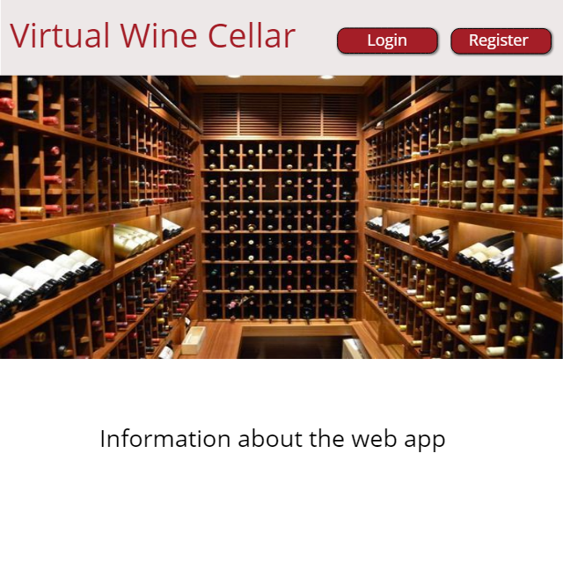

The login page where the user can enter in the account. 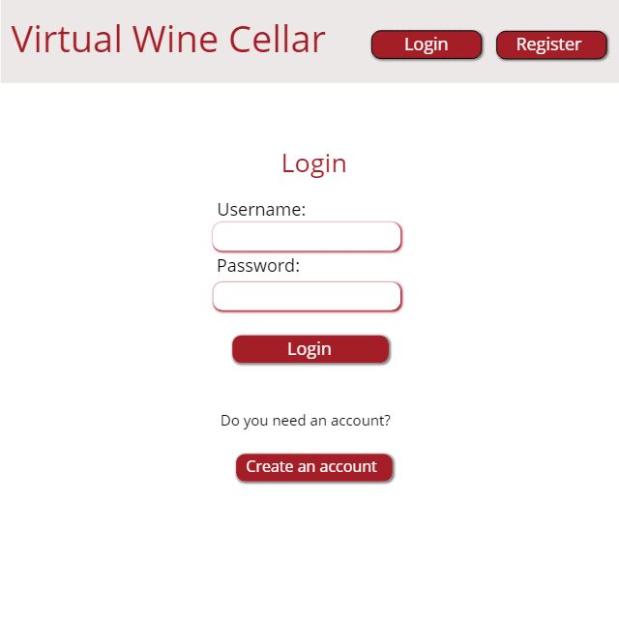

The register page where an unregister user can create an account. 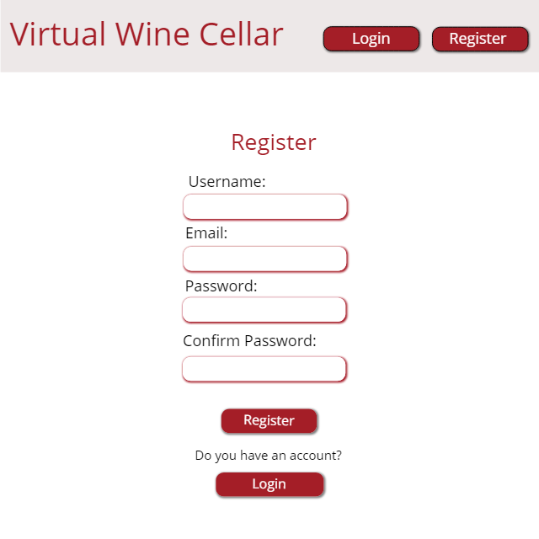

The cellar page where the user can look the collection. 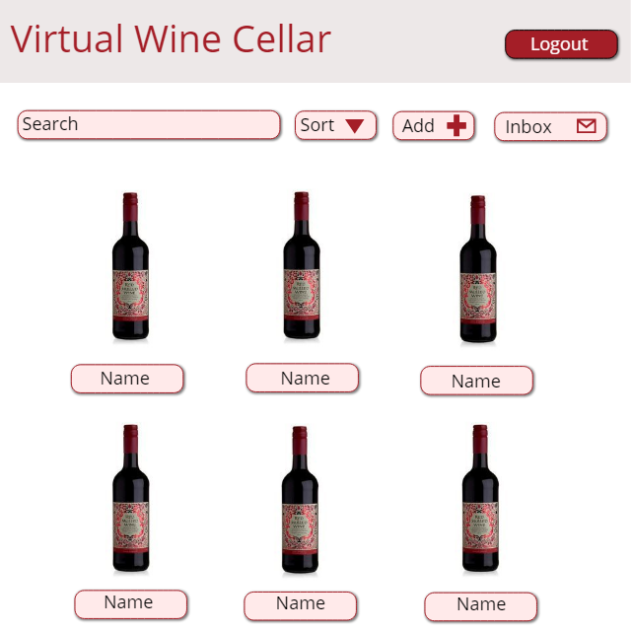

The information page where the user can look for the information of a specific wine. Also, can edit, share or scan the collection.

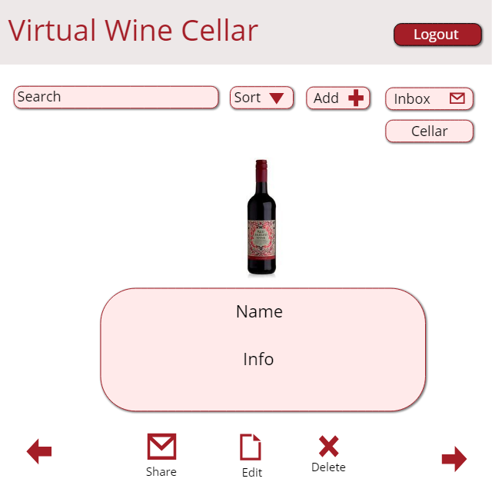

The add page where the user can add or edit a wine.

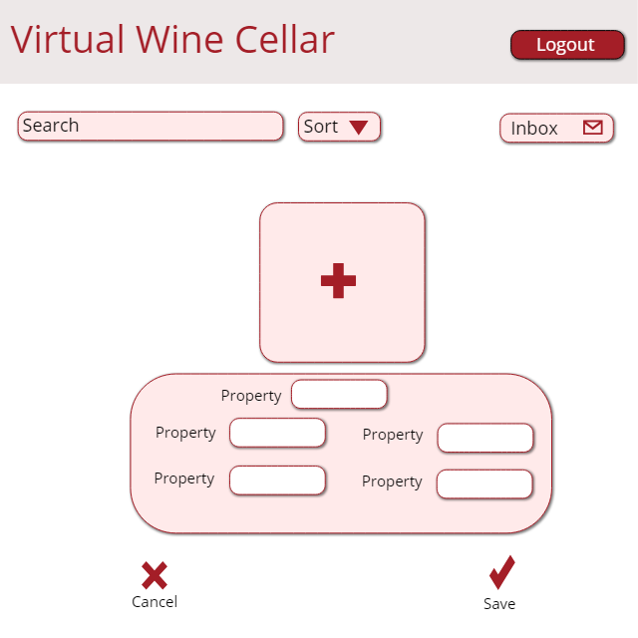

The inbox page where the user can look for the shared wines. 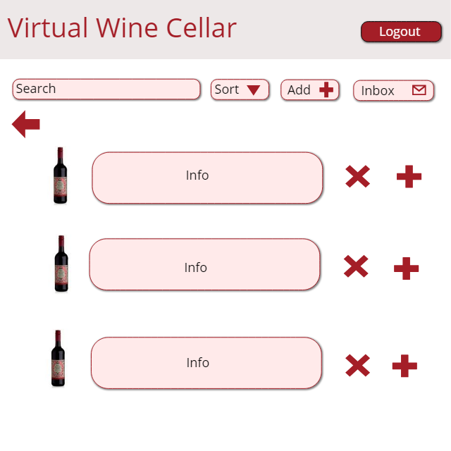

# **Project Plan**

* First Milestone
* Deadline – March 11, 2019
* Demo:
* Home Page
* Login Page and Register Page working for one user
* Base of the Cellar Page (Dashboard)
* Unit test of each class
* Second Milestone
* Deadline – March 29, 2019
* Demo:
* Backend
* Backend connected with the Frontend
* Database
* Unit tests
* Integration tests
* Third Milestone
* Deadline – April 12, 2019
* Demo:
* Features: add, edit, search, scan, share and receive an item.
* Unit tests
* Integration tests
* Acceptance tests

# **Deliverable Progress**

* First Deliverable
* Deadline – March 14, 2019
* Working software:
* Frontend using JavaScript, HTML, CSS and React framework.
* Base for the home page.
* Navigation bar with login and register links.
* Login page and register page working for one user.
* Base of cellar page indicating that the register and login was successfully.
* Unit tests for the frontend.
* Second Deliverable
* Deadline – April 1, 2019
* Working software:
* Backend using Python and Flask framework.
* Database in MySQL.
* Database with one table for store the information of users.
* Backend with register and login method connected to the database.
* Backend connected to frontend through Axios framework.
* The use of Axios to read the inputs from login and register page.
* Base of cellar page showing the user who is logging and a fixed wines list.
* Navigation bar in logging mode have a Logout and Cellar button.
* Third Deliverable
* Deadline – TBA
* In Progress